Palmetto Bengals

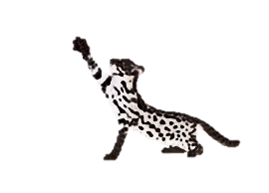
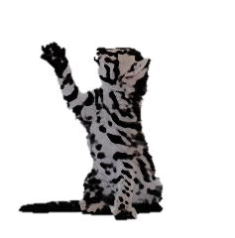
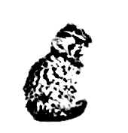

Early Generation Bengal Success Guide

Getting off to the right start!

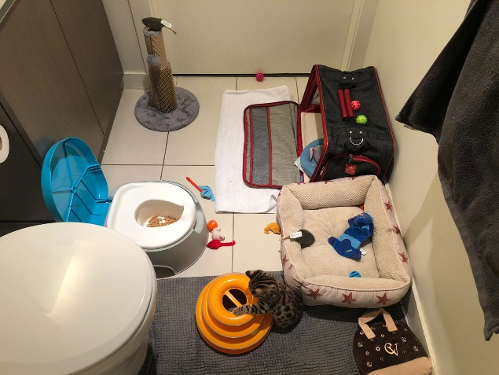
Once you bring your Palmetto Early Generation Kitten home, we recommend that you keep him calm and comfortable until he becomes accustomed to the new surroundings. We recommend that you first place your kitten in a small area, such as a bathroom with his food, water and potty prior to taking him or her on short excursions throughout the house, until they become familiar with their surroundings.

Things You Will Need
- Potty Of Choice
- Bed
- Crate
- Toys
- A Clean Floor

QUESTIONS & ANSWERS

- Our Kitten Keeps Crying, What Should I Do? Are They Okay?
Short Answer is YES
Your Palmetto EG Kitten may cry for the first 72 hours or hide under the bed or other small, dark spaces. Remember, it is scary for a kitten to leave his familiar surroundings! They need time to feel secure in their new home.
You May Leave Water out and dry food. We recommend feeding your kitten wet/raw by hand in person as much as possible. This allows them to bond with you as you are their new parent. This is a good method other than toys to lure them out of their comfort zone.

- What if our Palmetto Bengal EG Kitten Is Not Having Regular Bowl Movements?
Not Peeing or Pooping:
Please allow your babies nerves to settle enough to eat and drink within the first 72 hours. A lot of the time we hear this in the first 24 hours and it is nothing more than nerves. To ensure proper bowl movements please give your baby plenty of water. Water has been proven to be one of the best and safest laxitives.
Lose Stools: Again it is more than likely nerves. If it resides with in 24 hours you have nothing to worry about.
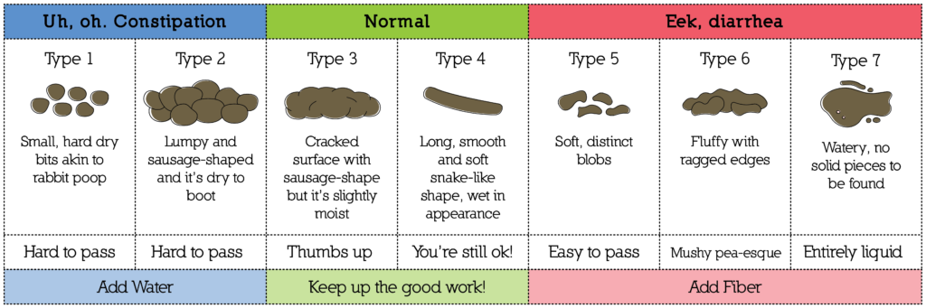

- What If My Bengal Kitten Has An Odd Color Stool?
Often Color of stool can be helpful in determining what may be going on with your Bengal kitten if this possible problem arises. It is best to talk to your veterinarian about any medical advice or ultimate conclusions. We have provided a color chart to give you a general idea of what to look for based on our personal experience but this does not replace a trip to the veterinarian.

Black — True dark black color to stool. Usually indicates bleeding high in the bowel. Severe sign, needs immediate attention.
Brown — Normal color. Be happy!
Orange — Usually indicates way too much bile in stool, can occur with reflux. Seek medical advice.
Yellow — Almost always indicates bacterial imbalance in the bowel. If has diarrhea also, usually related to coccidia. Seek medical advice.
White — Grossly abnormal color, usually indicates, severe bacterial imbalance and severe infection in the bowel. Kitten at risk of dying, needs medical attention, ASAP

- Do I have to take my Bengal to the Vet if they get sick? Can I just Google It or ask a group on Facebook?

Please take note that Google is not always right. Please do not risk your Bengals life based off of a few minutes or hours surfing the web compared to decades of education a Veterinarian would have. We have seen this method cost the lives of beloved pets.
Social media groups can be helpful at times again for a possible general idea. But do not let one or even a few that have “known someone with a Bengal” or “have their first Bengal” people sway you from a Certified Veterinarian with several Bengal Kittens under their belt.

- Can I just ask you or my breeder friends?
You can… However, I will give you much of same answers as above to insure I don’t put our baby at risk. I can only vouch for what I have seen or went through in the past 7 years. As for other Breeders I can not speak for them because I don’t know their personal experiences.

- How can I train my Bengal to use the toilet? How is that even possible?

Asian Leopard Cats Naturally eliminate in the water in the wild. Your Early Generation Bengal holds a percentage of the Asian Leopard Cat that directly links him to those unique instincts.
Below is our own proven method used with many of our families over the years. We believe getting your baby off to the right start with pre toilet training from the age of 3 weeks old starting with a simple bed pan that can be ordered for less than 10 dollars.

The world wide web is full of negative and false information on especially the F1 Bengal Cat. We believe that it is do to pure ignorance and neglect either from the Breeder or Owner. We have seen a few instances where it is both parties at fault. NOT THE F1/G1 BENGAL ITS SELF.
Palmetto Bengals believes that knowledge is power. And consistency is the key to success with any Early generation Bengal.

- How do I get my Early Generation Bengal To Use The Toilet? Do I order a kit online or use a kit from the store?

We have 3 phases that we follow and recommend in this guide. Photos was provided by one of our beloved Bengal Parents. We have tried several methods and “kits” this is the way that has worked the best. Some F1s will actually use the toilet all on their own.

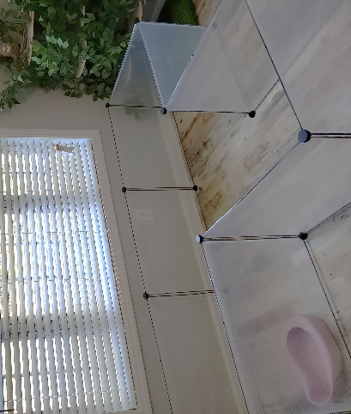
PHASE I
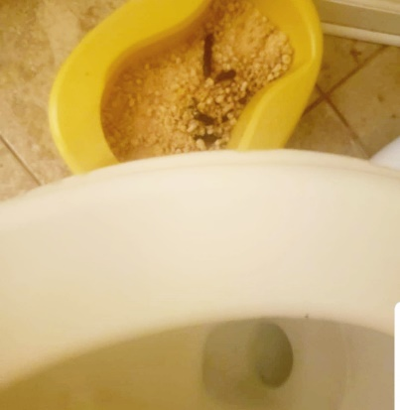

Our EG Bengal Nursery Set Up
Place your bed pan by your toilet at home. Use just enough to cover bottom of pan. They do sell Flushable for an easy dump and flush.
You may use an odor attractant to spray in pan. This can get more messy than needed. So, we prefer to use pine pellets and never cat litter!

PHASE II

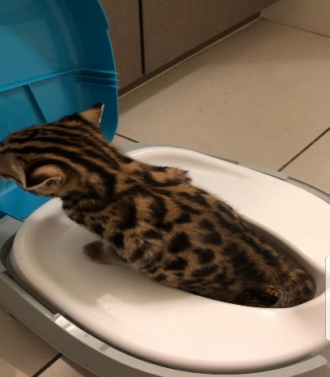
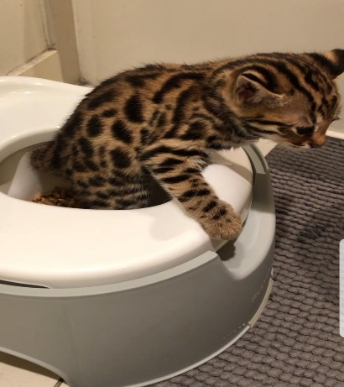
Use any toddler training potty until your baby is big enough to jump out of the big boy potty. Keep the big toilet lid closed for safety. Notice in the pictures above the small amount of pine pellets used.

PHASE III

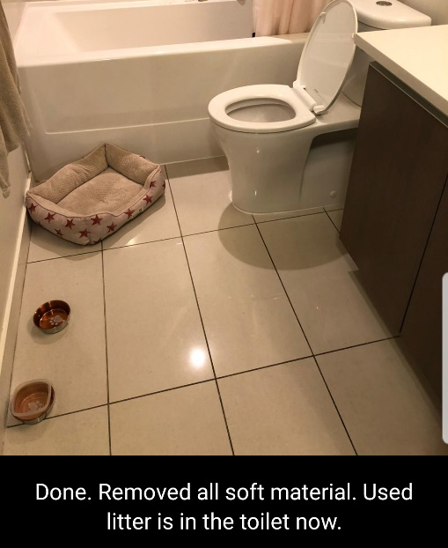

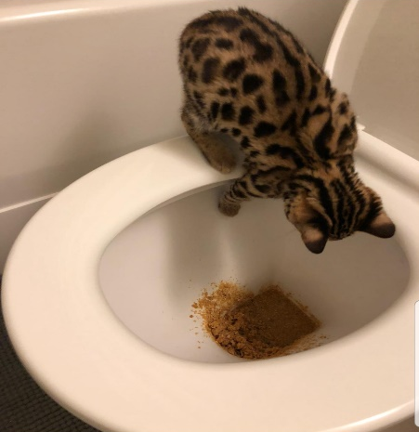
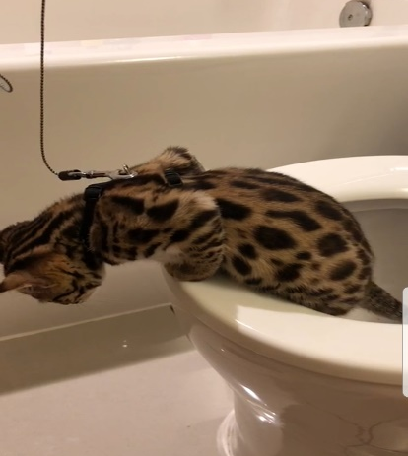
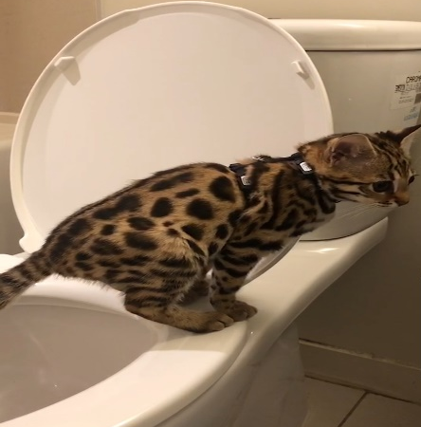
Once your Bengal Baby reaches the age of 16 weeks he should be able to jump on the toilet and out of it. Put just a few pellets for scent

Diet
Please feed raw chicken, beef, turkey, rabbit, deer, quail, squirrel and most any other meat if possible to mimic the food they would be getting in the wild.
We supplement with Wild Tracks that can be ordered online at www.wildtraxsupply.com
Wild Trax Feline Supplement Nutritional Benefits:
- Brewers Yeast - Wild Trax is made in a base of Brewers Yeast which contains high levels of many important nutrients, including all of the B vitamins (except for B12), 16 out of 20 amino acids, and 14 different minerals. The amino acids (proteins) in Brewers Yeast help the body repair tissue and fight disease. Minerals present in Brewers Yeast, including zinc, and high quality proteins assist in the control of shedding and promote a healthy skin and hair coat in animals.
- Higher Amounts of Taurine - compared to standard feline vitamins. Taurine is essential in the diet of cats and its deficiency results in a wide range of clinical signs including fetal abnormalities, delayed growth and development, central retinal degeneration and dilated cardiomyopathy.
- L-Lysine - boosts the feline immune system.
- Contains DL-Methionine - promotes urinary tract health and helps lowers urine odors.
- Additional B Vitamins - including B12. B vitamins aid in proper metabolism and increases energy levels. They also support the nervous system and help maintain the muscles used for digestion.
- Lecithin & Biotin - For healthy skin and shiny coat.
- Palatable - Our customers tell us their cats LOVE the taste of Wild Trax! The powdered consistency of Wild Trax also sticks well to meat.
Guaranteed Analysis:
Calcium Min 3.0%
Calcium Max 5.0%
Phosphorus Min 1.9%
Lysine Min 1.0%
Methionine Min 0.6%
Taurine Min 10.0%
Vitamin A min 300,000 IU/LB
Vitamin D3 Min 30,000 IU/LB
Vitamin E Min 6,000 IU/LB
Selenium Min 30 PPM

Can I feed commercial food to my EG Bengal?

Yes but NO MEOW MIX OR OTHER LOW QUAILITY CAT FOOD.

We recommend any cat food that is freeze dried raw and grain free. Some of the ones we use is
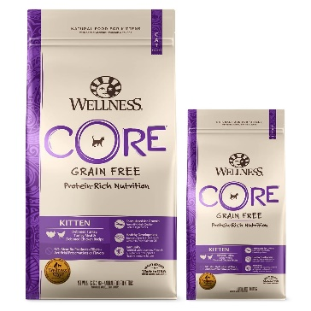
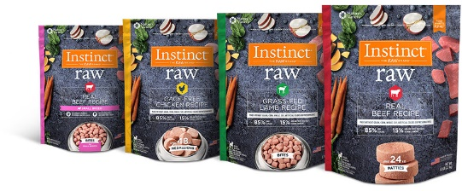
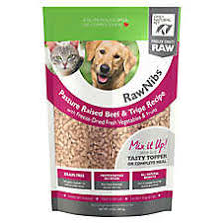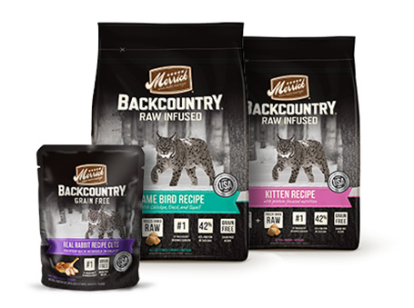

We are not responsible for any accidents that may come from this guide.

